Reverse Image Lookup: Assessing Digital Library Users and Reuses

Michele Reilly
Central Washington University
reillym@cwu.edu

Santi Thompson
University of Houston
Sathompson3@uh.edu

Abstract
Reverse image lookup (RIL) technology was used to assess the users and reuses of images from the Library of Congress’s Teaching with Primary Resources (LCTPR) digital collection. After selecting 44 images for the study, we used Google RIL to generate a dataset of over 1400 URLs. Drawing upon a coding rubric designed for a previous study on the ultimate uses of digital library materials, we coded the data to identify who uses these images and for what purposes. We found that the most popular type of user was “Personal,” which aligns with our previous work and indicates that a pattern is emerging between ultimate use and the Personal user type. Additionally, the study’s results indicate that Social Media and Popular Culture Research outnumbered any other type of reuse. This paper introduces RIL as a viable and approachable tool for digital library assessment and discusses its implications for assessment and content selection.

Keywords
Digital Library, Users, Reuse, Ultimate Use, Reverse Image Lookup

Introduction
Over the past twenty years, technology has allowed libraries to expand access to the content of their rare and unique special collections. The proliferation of digitized special collections images has created a wealth of online exhibits and image galleries for researchers and everyday users. As cultural heritage organizations continue to add content to their online collections, they have also begun to assess who is using digitized images and for what purposes.
Librarians have frequently focused their assessments on the usability of digital library platforms. In more recent years, others have also attempted to address how these materials were being used and reused -- a concept that is also known as “ultimate use.” Building on these previous studies, the researchers developed a project that utilized reverse image lookup (RIL) tools to better understand who uses digital library materials and for what purposes.
To conduct this study, the researchers constructed a dataset from the Library of Congress’s Teaching with Primary Resources (LCTPR) website. According to the LCTPR, “The Library of Congress collaborates with school districts, universities, libraries, and foundations to help teachers use the Library's vast collection of digitized primary sources to enrich their classroom instruction.” While the intent of the LCTPR is to bring digitized primary resources into the classroom, the researchers were curious to know if this intent translated to reuse on the web. Using data from the LCTPR collection, the researchers initially hypothesized that RIL queries would demonstrate that K-12 educators were the main users of these images and classroom instruction would be the primary reuses. To test this hypothesis, we assessed the reuse of selected LCTPR images using RIL. During this assessment we asked the following questions:
- Who is reusing LCTPR images on the web?
- For what purposes are LCTPR images being reused?
Reflecting on the responses to these questions, the researchers asked an additional question:
- What assessment implications does RIL present for digital library management?

This article will define RIL, review existing literature focused on digital library reuse case studies and the adoption of RIL as a tool to track reuse, present our methodology and results, discuss the merits and limitations of using RIL for digital library assessment, and conclude by outlining potential areas of future research. Based on this study, we maintain that RIL adds to the assortment of digital library assessment tools and techniques, such as conducting focus groups and surveys as well as analyzing queries on web-based question and answer services.
RIL Definition and Overview

Defined as “technologies that allow for the identification of reused images online,” (Terras and Kirton 2013) RIL tools search the internet for similar, exact, related, or manipulated instances of the image file as well as for the “popularity of an image” (Chutel and Sakhare 2014, 1431) over the web. (Chutel and Sakhare 2014, 1431; Wikipedia 2016) Examples of RIL include TinEye, Google Images, Bing Image Match, and Pinterest Visual Search Tool. RIL technology is the successor of content-based information retrieval (CBIR). Conceived of at a 1992 National Science Foundation workshop, CBIR searches image content, including the color, shape, and texture within an image, and retrieves exact or similar images (Eakins and Graham 1999). CBIR’s “underlying search algorithms” provide users with a variety of ways to search for images, including pre-existing or user drawn images, semantic retrieval, and relevance feedback (Wikipedia 2016). CBIR and RIL differ from traditional text-based query by using algorithms to analyze the content of the image. One advantage of RIL is that users do not need to know keywords or phrases to describe the image being searched.
Studies using RIL have also identified several limitations related to digital library assessment. One such limitation involves search results. These limitations include scenarios when URLs containing images matched by RIL are no longer available to the user (perhaps due to a webpage having a “dead link”), when access is restricted for a variety of reasons (including a “paywall” restriction), when a result yields a page on which a user cannot easily locate the image, when the search yields duplicate results, and when a search triggers a false positive (including results that do not match and are not similar to the original image queried) (Kelly 2015; Kousha, Thelwall and Rezaie, 2010,; Terras and Kirton 2013). Another limitation addresses search functionality. This problem includes issues related to Search Engine Optimization and indexing. Collections that have not been optimized, due to age or limited resources, will not be indexed by Google (Kelly 2015). Additionally, RIL searches HTML-indexed items only at this time, leaving images embedded in PDF and other popular publishing formats unsearchable (Kousha, Thelwall and Rezaie 2010). Readers should note that Google has been experimenting with indexing PDFs and other types of file formats; however, we could find no reliable information from Google related to the status or implementation schedule for this added functionality. A further limitation addresses image quality. Some RIL algorithms may struggle to match images that are below 300 pixels per inch (Kousha, Thelwall and Rezaie 2010).
While conducting this study, we unexpectedly encountered some of these RIL limitations, including the inability to discover un-indexed collections and the inability to distinguish one instance of an image from another. Just like Chapman et. al (2015), we observed that RIL algorithms are restrained by what files or digital objects are indexed by popular search engines. Chapman et. al., write that RIL cannot identify “images and digital objects hidden in larger, possibly un-indexed resource collections” (2015, 20). Additionally, RIL algorithms are not sophisticated enough to differentiate multiple instances of the same image originating from different sources or locations. Some of the images found in the LCTPR collection also exist in collections throughout the United States. When queried for such images, RIL is unable to pinpoint only LCTPR images. Because of this limitation, utilizing RIL to measure the use of a specific image from a specific source may be best suited for collections that are rare and unique to that source. Despite these limitations, we believe that RIL has the potential to offer digital library managers an additional tool for assessment. Our study offers one such example.

Literature Review
There are a variety of forces that shape the profession’s current understanding of digital library content reuse. The theoretical framework of this study concentrates on two of these forces – previous case studies assessing specific audiences’ ultimate uses and the adoption of RIL as a tool to track reuse over the web.
Perhaps the first to coin the term “ultimate use,” Beaudoin introduces the research area and uncovers barriers for assessing reuse. She writes, “while there have been many successful forays into discerning the phenomena surrounding image retrieval, the discipline has failed to address image users’ needs and how images are being used” (Beaudoin 2009, 68-69).
Beaudoin (2009) observed that this topic is “nearly without mention in the literature” (68-69). Since 2009, however, the body of literature on ultimate use is beginning to illustrate the diversity of digital library users and uses. In 2011, Górny and Mazurek (2012) developed a study to establish who digital library users are and for what purpose they are using digital libraries, with the intent of enhancing digital collection development activities. Chung and Yoon (2011) found that the majority of image reuses indicate that “users primarily seek images that will be used for illustrating particular ideas with appropriate images and for provoking thought patterns or inspirational ideas” (169) Supporting this theory, Reilly and Thompson (2014) reviewed the reuse of “digital cart” requested images from the University of Houston Digital Library and found that most reuses aligned with personal and non-scholarly pursuits, including personal research and popular culture publications. When attempting to understand reuse among historians and journalists, McCay-Peet and Toms (2009) found that a majority of image reuses were for illustrative purposes. As such, librarians should describe objects using both descriptive and conceptual attributes to increase the discoverability of images. Beaudoin (2014), analyzing image reuse among archaeologists, architects, art historians, and artists, concluded that the majority of uses addressed the "development of knowledge" (131). Valerie Harris and Peter Hepburn (2013), analyzing the potential reuse of images in scholarly historical articles, determined that professional historians are not drawing upon images from digital libraries. The cause, they speculate, is due to historians’ inability to locate images relevant to their research.
Subsequent studies have analyzed how RIL technology is used to examine content reuse over the web. In a 2008 article “Content-Based Information Retrieval and Digital Libraries,” Wan and Liu (2008) were two of the earliest researchers to introduce alternative search techniques to text-based searching, including audio, video, 3-D objects, and still images, to the library professional literature. Kousha, Thelwall and Rezaie (2010) and Terras and Kirton (2013) conducted their studies to have a better understanding of content reuse among a popular set of images (images of space and artwork, respectively). Using RIL, they found thousands of examples of reuse and categorized their results to show the variety of ultimate uses (e.g., art for commercial purposes and non-scholarly communication). Kelly (2015), who worked with a smaller sample size, also categorized reuse, finding that many images were repurposed by the home institution for educational purposes. Kelly also notes that while RIL has “historically been used primarily to locate commercial images without properly licensing,” (81) this same technology could also be used to track down how others are reusing images on the web.
This paper draws upon the growing interest in assessing reuse and the technology that makes such analysis possible on a larger scale in two key areas. First, the data set, with over 1,450 websites evaluated, produces one of the largest digital library RIL studies of its kind. Second, this study expands the profession’s understanding of ultimate use by using the web as our research population. It broadens the audience domain, which typically has focused on niche communities (professional historians, architects, artists, etc.).

Methodology
To generate the dataset used in this study, the researchers selected at least one image from each LCTPR lesson plan topic area (Teaching with Primary Resources 2016), which was usually the first image available. We identified several parameters that would make an image ineligible for the dataset due to RIL’s inability to search within complex, multi-page formats or moving image formats. These parameters included images within books, films, ephemera, and those with poor image quality. If the image did not fall within the study’s parameters, another image was chosen from the lesson plan gallery. The selection process generated 44 viable images.
Each image was uploaded to Google Reverse Image search to discover cases of reuse. The researchers chose to include the top 25 search results from each image to populate the dataset. Initially, we were documenting the top 50 but found that results after the first 25 became less useful. Specifically, we encountered irrelevant pages, pages without images, and pages with damaging content (phishing, malware, etc.). The final dataset included over 1400 URLs.
The search results were then normalized in several ways to decrease the opportunities for anomalies. First, Google’s search algorithms would omit some entries. When delivering search results, Google search stated, “In order to show you the most relevant results, we have omitted some entries very similar to the (number) already displayed.” The researchers elected to repeat the search with the omitted results included to ensure the results were the same across all image searches. Second, the researchers removed URLs that were from the loc.gov domain or produced by the Library of Congress because we interpreted this not to be reuse. Third, we omitted duplicate images in various contexts, including duplicate images from the same vendor with a different description, tag, or URL. An example would be http://www.zazzle.com/teddy+roosevelt+posters was selected, but http://www.zazzle.com/john+muir+gifts was omitted. After distilling the search results, we were left with 721 websites to analyze.
We utilized an existing coding rubric from our previous study to classify the dataset (Reilly and Thompson 2014). To assess the “Type of User” and the “Type of Use,” we selected each URL, viewed the content on that page, and then viewed content on the “About Us” page, if available. A Google spreadsheet was used to record the types of users and uses and the ‘explore’ feature was employed to visualize the results.
See Table 1 for definitions of the user types. See Table 2 for definitions of the reuse types.

Results
After compiling the results, we found that half of all users fell into the Personal category, followed by Industry, which comprised a quarter of the total use types (see Table 3). The remaining 25 percent fell into the other types of users as defined in Table 1.
Additionally, we compiled results for the types of reuses (see Table 4). Nearly one-quarter of all reuse types fell under the category of Social Media. Approximately one-in-five responses were assigned to the Popular Culture Research category. The Commerce, Exhibit, Instruction, and Scholarly Research categories all received around ten percent of the total. The other types of reuses, defined in Table 2, shared the remaining thirteen percent of the total.
Discussion
Question One: Who is reusing LCTPR images on the web?
Using LCTPR’s mission statement as a baseline for hypothesizing who the primary users of these digital images are suggests that the user type educators, in both the K-12 and higher education categories, would yield the most results. After collecting and coding the data, the researchers found that educators comprised not quite 10 percent of the total responses.
However, the most popular type of user, at 50 percent, was in the Personal category. This result aligns with other research on ultimate use and the users of digital library materials. Górny and Mazurek (2012) ascertain that “a relatively stable group of users of digital libraries in Poland consist of persons interested in local history and amateur genealogists. This is a dominant group, accounting for 60 per cent [sic] of all users” (552). Górny and Mazurek’s results correlate with the data collected and analyzed in this study. These studies all indicate an emerging pattern of digital image reuse among the Personal user type.
Question Two: For what purposes are LCTPR images being reused?
Since we compiled the data set from LCTPR images, one might assume that the majority of reuses would fall into the category of Instruction. After analyzing the results, we concluded that K-12 instruction was not the most popular reuse of LCTPR material. The study’s findings demonstrate that Social Media and Popular Culture Research outnumbered any other type of reuse.
As the most popular type of reuse, Social Media instances from the data showed users repurposing LCTPR content for personal motivations. An overwhelming majority of Social Media reuses came from Pinterest. Frequently, pinner biographical information gives evidence to the strong personal connection users have with the digital objects they reuse. For example, one pinner identifies as, “Publications professional. Husband. Dad. Doodler. Baseball fan. Imaginary musician. Cheeseburger addict." The pinner’s corresponding pinboard focuses on historical baseball images, predominantly baseball cards (see Figure 1). Pinterest content comprised the majority of reuse on social media. A marginal number of other social media sites, including Tumblr and Flickr, were represented. However, these numbers were so small that we elected not to highlight these results.

FIGURE 1: Pinterest Screenshot of Baseball Pinboard

Popular Culture Research was also a prominent type of reuse among LCTPR images. Personal blogs comprise most instances of this reuse type. One example shows a blogger reusing historic images to discuss various topics of personal interest to the blog owner (see Figure 2).

FIGURE 2: Screenshot of “History in Photos”
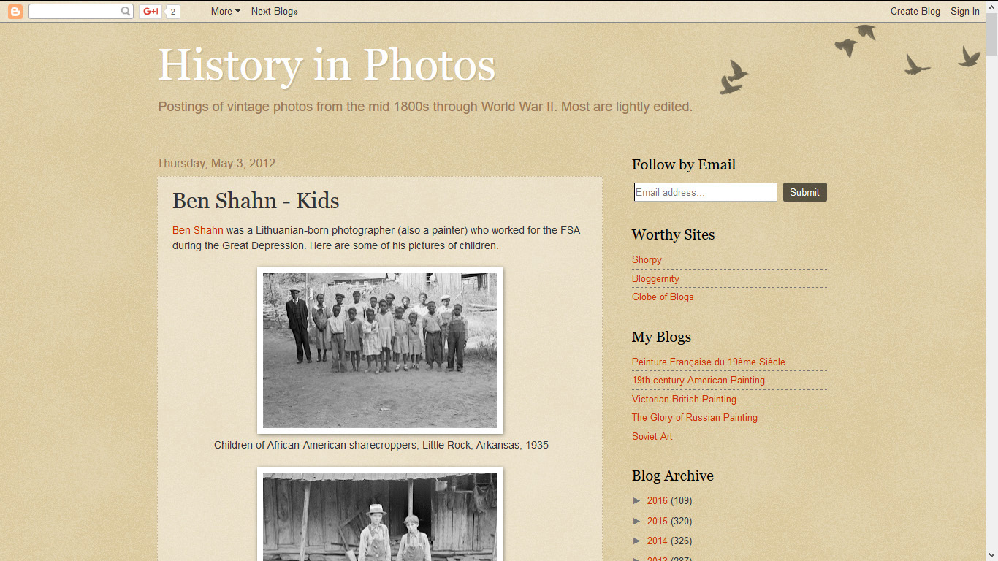

The prominent number of Personal reuse types, such as Social Media and Popular Culture Research, were not surprising given that personal, everyday users of digital library content were the largest user type in the dataset.
The third most popular type of reuse was Commerce. This reuse corresponds closely to the Industry user type, which comprised a considerable number of overall users in the dataset. Most instances of Commerce were the selling of physical prints derived from digital library objects. For example, the private publisher Shorpy.com frequently printed and framed LCTPR images and made them available for purchase via its website (see Figure 3).

FIGURE 3: Shorpy.com
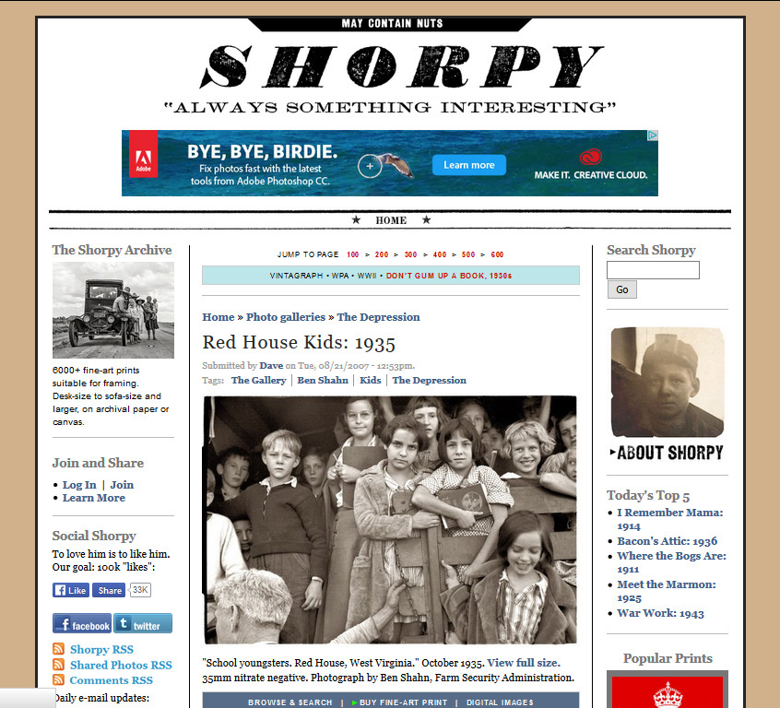
As noted in the Results section of this paper, other reuse types did not score a significant percent of total reuses. Some might be surprised at the small numbers of Scholarly Research, Instruction, and Scholarly Publications reuse types given the purpose and context of the LCTPR website. The small number of non-personal reuses, however, was not inconsistent with previous researchers’ and our earlier work on “ultimate use.” For example, Gorny and Mazurek (2012), when studying users and reuse, write that, “non-scholarly research comprises most of the intended use of Polish digital libraries” (552).
Question Three: What assessment implications does RIL present for digital library management?
RIL technology offers various assessment advantages for digital library managers. These implications include both a low barrier for implementation and a broader scope of data for analysis. Some obvious benefits of RIL are that it is primarily free and web-based, requiring no special software to run an assessment. Additionally, as RIL websites have evolved, many allow queries to be formed in a variety of ways: using drag and drop functionality to query the image, using the URL of the image as the search query, and using text descriptors to query images with specific qualities or attributes. Because RIL continues to be enhanced, future functionality (such as querying images in PDFs) could yield more comprehensive reuse results.
Additionally, RIL technology expands the kinds of data collected for digital library assessment, irrespective of the institution, digital library, or digital collection from which an image is derived. Because RIL’s platform queries the web, it has the potential to reach billions of websites and users. This feature dramatically increases the data sources compared to traditional assessments, which may typically rely on focus groups or survey respondents for data collection. With this greater ability to produce potentially millions of results also comes difficulties in limiting and analyzing mass quantities of data. Digital library managers will have to develop common methodologies suited to their local needs to make this type of analysis more manageable, such as limiting the results, removing duplicates, and capturing website results as PDFs to combat broken URLs from disabling access in the future.
Beyond assessment methods, RIL technology offers digital library managers the opportunity to draw upon user-driven data to inform digital collection selection decisions. In a previous study, we identified a connection between reuse and digital library selection:
Digital library best practices often state that selection decisions are based on a host of criteria, including uniqueness, intellectual value, physical condition, copyright status, and institutional priorities. While the authors believe that ultimate use should be another criterion when making content selections, this approach is often underutilized by selectors, perhaps in part because the mechanisms and the data needed to determine ultimate use are difficult to implement and laborious to collect. (Reilly and Thompson 2014, 210)
RIL assessment tools offer a low-barrier mechanism for identifying reuse trends.

Conclusion
The results of using RIL assessment gives libraries an expansive view on how users are repurposing digital content on the web. Knowing this information offers librarians valuable information about digital libraries, their users, and how content is being repurposed. The researchers’ data indicates that everyday users are repurposing digital content in ways that are meaningful to them and acknowledges and fulfills personal interests. These users are also sharing this content through a variety of environments on the web, including popular social media platforms, blogs, and personal websites. Our study, in addition to others addressing the reuse of digital objects, reflects the value of recognizing diverse user groups who engage with digital library content. Our study reinforces values expressed by Baggett and Gibbs (2014), who argue that special collections environments should expand their attention and services beyond “the groups that special collection departments have traditionally served—students, faculty, and academic researchers” (17). Assessment tools like RIL make it possible to discover these alternative user groups.
While completing this study, we identified key limitations that should be acknowledged when considering the results. One limitation addresses the inability of RIL to account for all types of user behavior. In the context of our study, for example, educators may be reusing LCTPR content outside of the web environment or in other ways that are not easily queried by RIL. Another limitation of our study is our decision to query images from one discrete digital collection. Additional RIL studies utilizing multiple collections across different institutions may not yield results similar to ours. As such, information professionals need to acknowledge the limitations and challenges of using RIL tools for digital library assessment.
The researchers’ also recognize several ways that information professionals can contribute to future research related to utilizing RIL as an assessment tool. Topics could include:
- Understanding the similarities and differences among the growing body of RIL software
- Comparing key functionality and metrics across RIL platforms, such as accuracy rates, total numbers queried, depth of search (beyond items in HTML format), and linking a still image to its parent moving image file
- Testing RIL software against a heterogeneous mixture of digital collection materials from disparate sources
Acknowledging our results, the limitations that exist, and the areas of ongoing research all demonstrate how RIL is one innovative tool that can be used in conjunction with others to better assess digital library users and reuses. The adoption of RIL as an assessment mechanism should entice librarians and information professional to “look outside the box” for other unorthodox tools that could be part of a robust toolkit for assessing digital libraries.

Acknowledgements

The researchers would like to thank the following individuals for their contributions to the development of this research project: Emily Hanson, Sanjica Faletar Tanackovic, PhD (LIDA 2016), and Becky Severin.

References
Baggett, Mark, and Rabia Gibbs. 2014. "Historypin and Pinterest for Digital Collections: Measuring the Impact of Image-based Social Tools on Discovery and Access." Journal of Library Administration 54, no. 1: 11-22.
Beaudoin, Joan Elizabeth. 2009. "An Investigation of Image Users across Professions: A Framework of Their Image Needs, Retrieval and Use." PhD diss., Drexel University. http://idea.library.drexel.edu/bitstream/1860/3160/1/Beaudoin_Joan.pdf.
Beaudoin, Joan E. 2014. "A Framework of Image Use among Archaeologists, Architects, Art Historians and Artists." Journal of Documentation 70, no. 1: 119-147.
Chapman, Joyce, Jody DeRidder, Megan Hurst, Elizabeth Joan Kelly, Martha Kyrillidou, Caroline Muglia, Genya O’Gara, Ayla Stein, Santi Thompson, Rachel Trent, Liz Woolcott, Tao Zhang. 2015. “Surveying the Landscape: Use and Usability Assessment of Digital Libraries,” Digital Library Federation Assessment Interest Group, User Studies Working Group. doi:10.17605/OSF.IO/9NBQG.
Chung, EunKyung, and JungWon Yoon. 2011. "Image Needs in the Context of Image Use: An
Exploratory Study." Journal of Information Science 37, no. 2: 163-177.
Chutel, Pushpa and Apeksha Sakhare. 2014. “Evaluation of Compact Composite Descriptor
Based Reverse Image Search.” Paper presented at the International Conference on Communication and Signal Processing.
Eakins, John P., and Margaret E. Graham. 1999. Content-based Image Retrieval, a Report to the
JISC Technology Applications Programme.
Google. 2016. “Quickly Get Insights on a Spreadsheet Using Explore,” Last modified 2016.
https://support.google.com/docs/answer/6280499?hl=en.
Górny, Miroslaw, and Jolanta Mazurek. 2012. "Key Users of Polish Digital Libraries." The
Electronic Library 30, no. 4: 543-556.
Harris, Valerie, and Peter Hepburn. 2013. "Trends in Image Use by Historians and the Implications for Librarians and Archivists." College & Research Libraries 74, no. 3: 272-287.
Kelly, Elizabeth Joan. 2015. "Reverse Image Lookup of a Small Academic Library Digital Collection." Codex: the Journal of the Louisiana Chapter of the ACRL 3, no. 2: 80-92.
Kousha, Kayvan, Mike Thelwall, and Somayeh Rezaie. 2010. "Can the Impact of Scholarly Images Be Assessed Online? An Exploratory Study Using Image Identification Technology." Journal of the American Society for Information Science and Technology 61, no. 9: 1734-1744.
Linder, Rhema, Clair Snodgrass, and Andruid Kerne. 2014. "Everyday Ideation: All of My Ideas Are on Pinterest." In Proceedings of the 32nd Annual ACM Conference on Human Factors in Computing Systems, pp. 2411-2420. Paper presented at Association for Computing Machinery, Toronto, Canada, April 26 - May 1.
McCay-Peet, Lori, and Elaine Toms. 2009. "Image Use within the Work Task Model: Images as Information and Illustration." Journal of the American Society for Information Science and Technology 60, no. 12: 2416-2429.doi:10.1002/asi.21202.
Reilly, Michele, and Santi Thompson. 2014. "Understanding Ultimate Use Data and Its Implication for Digital Library Management: A Case Study." Journal of Web Librarianship 8, no. 2: 196-213.
Teaching with Primary Sources Program. 2016. "The Teaching with Primary Sources Program." Library of Congress. Accessed February 14, 2016. http://www.loc.gov/teachers/tps/.
Terras, M. M., and I. Kirton. 2013. "Where Do Images of Art Go Once They Go Online? A Reverse Image Lookup Study to Assess the Dissemination of Digitized Cultural Heritage.” Paper presented at the Museums and the Web Conference. Portland, OR. April 17-20. http://mw2013.museumsandtheweb.com/paper/where-do-images-of-art-go-once-they-go-online-a-reverse-image-lookup-study-to-assess-the-dissemination-of-digitized-cultural-heritage/.
Wan, Gary Gang, and Zao Liu. 2008. "Content-based Information Retrieval and Digital
Libraries." Information Technology and Libraries 27, no. 1: 41-47
Wikipedia. 2016. “Content Based Image Retrieval.” Last modified July 11.
https://en.wikipedia.org/wiki/Content-based_image_retrieval.

For more on the usability assessment of digital library software, see: Agosti, M., F. Crivellari, G.M. Di Nunzio, and S. Gabrielli. 2011. “Understanding User Requirements and Preferences for a Digital Library Web Portal.” International Journal on Digital Libraries 11, no. 4: 225–238, retrieved from http://link.springer.com/10.1007/s00799-011-0075-7; Alonso Gaona García, P., D. Martín-Moncunill, S. Sánchez-Alonso, and A. Fermoso García. 2014. “A Usability Study of Taxonomy Visualisation User Interfaces in Digital Repositories,” Online Information Review 38, no. 2: 284–304, retrieved from http://www.emeraldinsight.com/doi/abs/10.1108/OIR-03-2013-0051; Dobreva, M. and S. Chowdhury. 2010. “A User-Centric Evaluation of the Europeana Digital Library,” The Role of Digital Libraries in a Time of Global Change 6102, ed. G. Chowdhury, C. Koo, and J. Hunter, 148–157. doi:10.1007/978-3-642-13654-2_19; Hariri, N. and Y. Norouz. 2011. “Determining Evaluation Criteria for Digital Libraries’ User Interface: a Review,” The Electronic Library 29, no. 5: 698–722, retrieved from http://www.emeraldinsight.com/doi/abs/10.1108/02640471111177116.
Includes information from a presentation made at International Conference Libraries in the Digital Age (LIDA), Zadar, Croatia, June 13-17, 2016.
For an example, see Beaudoin, Joan Elizabeth. 2014. “A Framework of Image Use among Archaeologists, Architects, Art Historians and Artists” Journal of Documentation 70, no. 1: 119-147.
For an example, see Chung, EunKyung and JungWon Yoon. 2011. "Image Needs In the Context of Image Use: An Exploratory Study." Journal of Information Science: 163-177.
For an example of ephemera, see “An American Time Capsule: Three Centuries of Broadsides and Other Printed Ephemera” from the Library of Congress’s American Memory website: http://memory.loc.gov/cgi-bin/ampage?collId=rbpe&fileName=rbpe12/rbpe122/1220360b/rbpe1220360b.db&recNum=0.
According to Google, the explore feature permits the user to “see automatic charts and analysis based on the data in your spreadsheet.” This allows the user to “find patterns in your data and add the charts directly to your spreadsheet.” (Google 2016)

